**Use Case Diagram**

**Actors:**

**-**User (Student): Engages with the energy usage monitor to track and manage energy consumption.

**- Energy Usage Monitor System:**

Central system that collects, analyzes, and presents data on energy usage.

Use Cases:

1. **Monitor Energy Consumption**:

- The user views real-time energy usage data.

- The system displays energy consumption for individual devices and overall usage.

2. **Receive Alerts:**

- The system notifies the user when energy consumption exceeds set thresholds.

- Alerts may include reminders to unplug devices or turn off lights.

3. **Analyze Usage Patterns:**

- The user can access historical data to understand energy usage trends.

- The system provides graphical representations of energy consumption over time.

4.**Set Energy-Saving Goals:**

- The user sets individual goals for energy savings.

- The system tracks progress toward these goals and provides feedback.

5.**View Recommendations:**

- The system suggests energy-saving practices based on usage data.

- Recommendations may include optimal usage times for devices or alternative energy sources.

**Sequence Diagram**

**Scenario: Monitoring Energy Consumption**

1. **User Launches Application:**

The user opens the energy usage monitor app.

2. **System Requests Device Data**:

The application sends a request to connected devices for their current energy usage.

3. **Device Sends Data:**

Each connected device transmits its energy consumption data back to the system.

4. **System Processes Data:**

The energy usage monitor aggregates the data from all devices.

5. **System Analyzes Data:**

The system analyzes the collected data to identify trends and identify any excessive usage.

6. **System Updates User Interface:**

The system updates the user interface with real-time data and any alerts.

7**.User Receives Notifications:**

If any thresholds are exceeded, the system sends notifications to the user.

**Diagrams for Functional Components**

**Functional Components Diagram**

Below is a textual representation of the functional components diagram, which can be visualized as a block diagram:

1. **Data Acquisition Module**

- Function: Collects real-time energy consumption data from connected devices (smart plugs, IoT devices).

- Inputs: Energy usage data from devices.

- Outputs: Raw data for processing.

2**. Data Processing Engine**

- Function: Analyzes and aggregates data to identify usage patterns and anomalies.

- Inputs: Raw energy consumption data.

1. - Outputs: Processed data, analysis results, and insights.

**3. User Interface Module**

- Function: Provides a user-friendly interface for interaction.

- Inputs: User actions (view, set goals, etc.).

- Outputs: Visualizations of data, alerts, and recommendations.

4. **Notification and Alert System**

- Function: Sends alerts and notifications to users based on predefined thresholds.

- Inputs: Processed data indicating excessive usage.

- Outputs: Notifications to the user (e.g., alerts, recommendations).

5. **Goal Setting and Tracking Module**

-Function: Allows users to set energy-saving goals and monitor their progress.

- Inputs: User-defined goals.

- Outputs: Progress reports and recommendations for achieving goals.

**A developed diagram for the sequence components**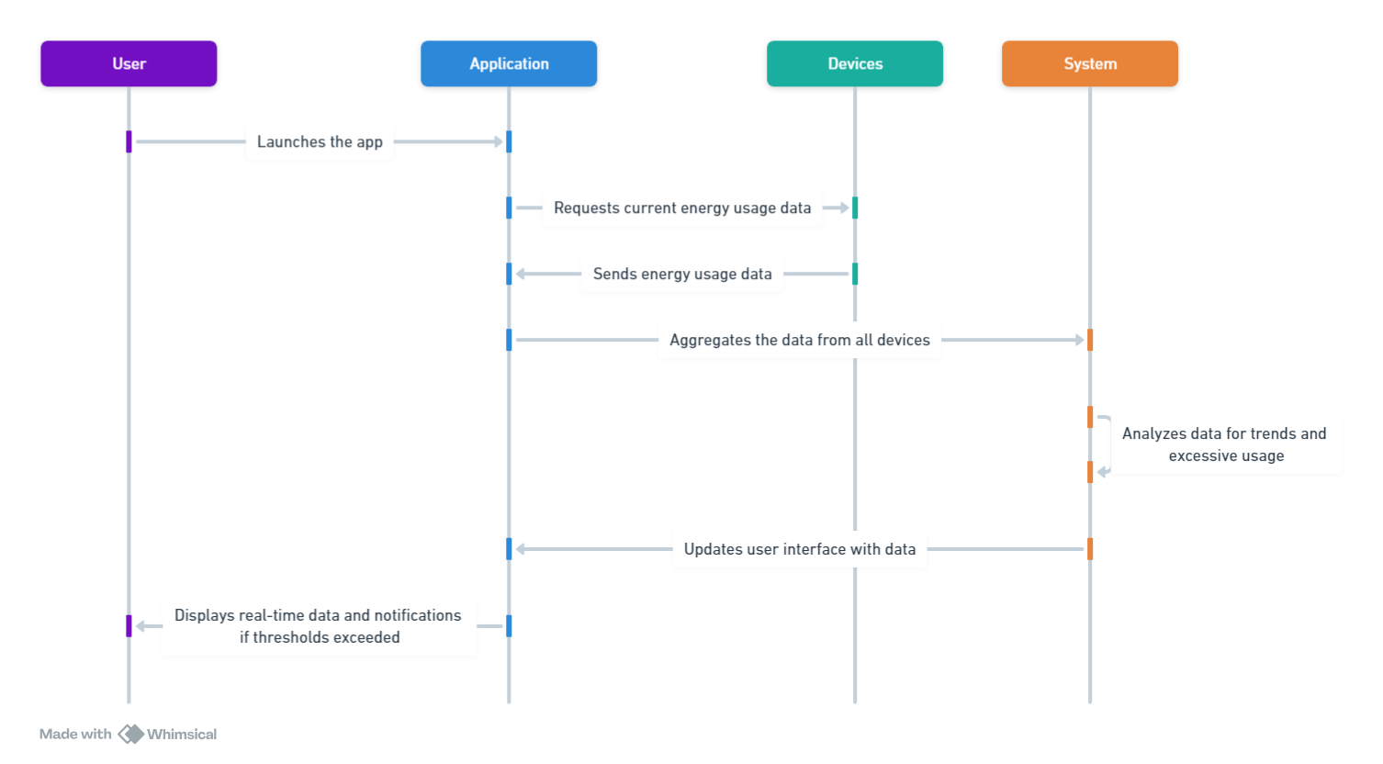

**Use case diagram**

Energy monitor

sysstem

View recommendations

Self energy saving goals

Actor 1

Analyses usage patterns

Receives alerts

uci